# Coursera - IBM Data Science Applied Data Science Capstone

*A project report on*

**Car Accident Severity Prediction**

*By*

**Akshay Surve**

**2/10/2020**

## Introduction

In this fast-moving world, no one is safe. The whole world suffers due to car accidents. Thousands of people loses their life in car accidents due to some controllable factors like not paying enough attention during driving, abusing drugs and alcohol or driving at very high speed or some uncontrollable factors like weather, visibility, or road conditions. We are trying to solve this problem by giving warning to driver and remind them to drive carefully in critical situations. We are going to predict accident severity depending upon the factors such as current weather, road and visibility conditions which are already given to us. This project aims to reduce numbers of car accidents on highway in Seattle. The target audience of the project will be local government, police and car insurance companies.

## Data Understanding

### Data Collection

I have considered Seattle Collision Dataset for solving this problem. I have downloaded this data set from https://s3.us.cloud-object-storage.appdomain.cloud/cf-courses-data/CognitiveClass/DP0701EN/version-2/Data-Collisions.csv It contains 194673 observations. It's having total 37 columns from which 37 are attributes and 1 is severity label.

We are going to predict "SEVERITYCODE" as a target variable. Data set is already labled with 0 - Property damage only. 1- Severe Injury. We are going to use this data set for supervise learning data model. Before starting we need to clean the data as it's having many unnecessary attributes and missing values.

### Features

The data set contains 38 columns:

* + 1. SEVERITYCODE: A code that corresponds to the severity of the collision.
    2. X: The longitude
    3. Y: The latitude
    4. OBJECTID: ESRI unique identifier
    5. INCKEY: A unique key for the incident
    6. COLDETKEY: Secondary key for the incident
    7. REPORTNO: Report number
    8. STATUS: Match or unmatch
    9. ADDRTYPE: Collision address type: Alley, Block, Intersection
    10. INTKEY: Key that corresponds to the intersection associated with a collision
    11. LOCATION: Description of the general location of the collision.
    12. EXCEPTRSNCODE: Enough or not enough information
    13. EXCEPTRSNDESC: Enough or not enough information
    14. SEVERITYCODE: Duplicated column
    15. SEVERITYDESC: A detailed description of the severity of the collision
    16. COLLISIONTYPE: Collision type
    17. PERSONCOUNT: The total number of people involved in the collision
    18. PEDCOUNT: The number of pedestrians involved in the collision. This is entered by the state.
    19. PEDCYLCOUNT: The number of bicycles involved in the collision. This is entered by the state.
    20. VEHCOUNT: The number of vehicles involved in the collision. This is entered by the state.
    21. INCDATE: The date of the incident.
    22. INCDTTM: The date and time of the incident.
    23. JUNCTIONTYPE: Category of junction at which collision took place
    24. SDOT_COLCODE: A code given to the collision by SDOT.
    25. SDOT_COLDESC: A description of the collision corresponding to the collision code.
    26. INATTENTIONIND: Whether or not collision was due to inattention. (Y/N)
    27. UNDERINFL: Whether or not a driver involved was under the influence of drugs or alcohol.
    28. WEATHER: A description of the weather conditions during the time of the collision.
    29. ROADCOND: The condition of the road during the collision.
    30. LIGHTCOND: The condition of the road during the collision.
    31. PEDROWNOTGRNT: Whether or not the pedestrian right of way was not granted. (Y/N)
    32. SDOTCOLNUM: A number given to the collision by SDOT.
    33. SPEEDING: Whether or not speeding was a factor in the collision. (Y/N)
    34. ST_COLCODE: A code provided by the state that describes the collision.
    35. ST_COLDESC: A description that corresponds to the state’s coding designation.
    36. SEGLANEKEY: A key for the lane segment in which the collision occurred.
    37. CROSSWALKKEY: A key for the crosswalk at which the collision occurred.
    38. HITPARKEDCAR: Whether or not the collision involved hitting a parked car. (Y/N)

## Exploratory Data Analysis

### Data Preparation

The problem is predicting the severity code by using the independent variables. Hence, it is a classification problem. The "severity" depends on the following data:

* + 1. Accident location: Latitude("Y" column - float), Longitude("X" column - float)
    2. Road coditions: "ROADCOND" column - text
    3. Weather condition: "WEATHER" column - text
    4. Junction: "JUNCTIONTYPE" column - text
    5. Car speeding: "SPEEDING" column - boolean
    6. Number of people involved: "PERSONCOUNT" column - integer
    7. Light conditions: "LIGHTCOND" column - text
    8. Number of vehicles involved in: "VEHCOUNT" column - integer
    9. The date time when the accident occurs: "INCDATE", "INCDTTM" columns - text

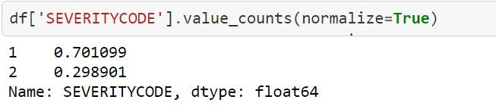

We can see that the dataset contains only 2 severities: "1" (prop damage) and "2" (injury). It will limit the prediction because the classification can not perform with the label which doesn't exist in dataset such as "3" (fatality), "2b" (serious injury) and "0" (unknown).

Further, we've to drop the missing value of the longitude and latitude in order to data preparation. Also later we’ve to encode the categorical data, one of the example is given below.

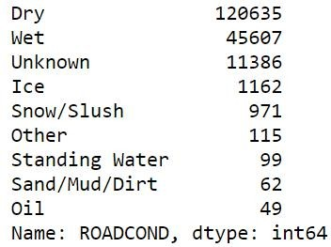 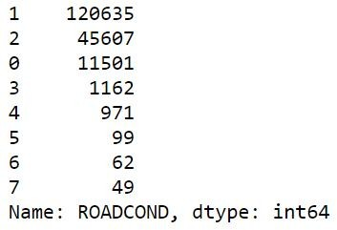

We’ll perform same operation for other attribute such as WEATHER, JUNCTIONTYPE, and LIGHTCOND.

### Model Building

It is very essential to build a model that can be used to further development of the project and end up giving useful results in order to predict the severity.

In this analysis we are going to used following models as we find our categorical:

1. K Nearest Neighbor (KNN)
2. Decision Tree
3. Logistic Regression

We’ll start with this importing necessary libraries and splitting the dataset into train and test dataset.



And then we implement our models accordingly.

### Model Evaluation

Evaluation is important as it shows the clear picture of how much efficient the models were after being trained and tested.

|  |  |  |  |
| --- | --- | --- | --- |
| In this project F1-Score and Jaccard Score are used as evaluation metrics. And the table below depicts the result.  **Metrics / Models** | **KNN** | **Decision Tree** | **Logistic Regression** |
| **F1-Score** | 0.64 | 0.66 | 0.62 |
| **Jaccard Score** | 0.47 | 0.52 | 0.47 |

### 3.4 Model Conclusion

From the above evaluation of different classification models, we can observe that F1-score of the different models didn't varied much, yet, Logistic Regression model was significantly better choice for the project (score = 0.62). However, according to Jaccard Score both KNN and Logistic Regression equally suits the requirement with score of

0.47. It can be concluded that three models chosen for the development and evaluation are being studied and verified altogether.

# Conclusion

The exploratory analyses of the extracted dataset and the models that were built in order to develop a proper system that can predict car severity for the intended target audience mentioned in previous section of this documented report. This project is also going to help individual in determining the best model among chosen ones.